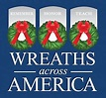
Each December on National Wreaths Across America Day, our mission to Remember, Honor and Teach is carried out by coordinating wreath-laying ceremonies at Arlington National Cemetery, as well as at more than 2,100 additional locations in all 50 U.S. states, at sea and abroad.
Join us by sponsoring a veterans’ wreath at a cemetery near you, volunteering or donating to a local sponsorship group.

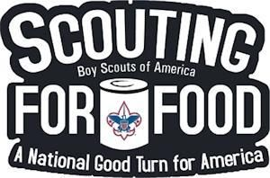

Scouting for Food is an ongoing annual program of the Boy Scouts of America, begun in 1985 by the Greater Saint Louis Area Council. The program involves collecting for local food banks. It is organized at the local level throughout the country. Scouting for Food is a project rooted in the very foundation of the Scouting movement and its dedication to implement the Scout Slogan and do a good turn

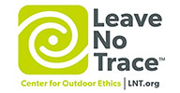

As an American, I will do my best to
Be clean in my outdoor manners,
Be careful with fire,
Be considerate in the outdoors,
and be conservation-minded.

